Manchester High School
Business Education Program _________________________
CTAE Mission: To provide experiences that will prepare students for postsecondary and workforce success.
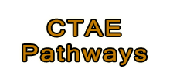
Business Education Pathways are available to prepare students for employment and /or continuing education opportunities in business through technical instruction in the classroom, experiential education in the laboratory, student internships, and through leadership and personal development by participating in student leader organizations.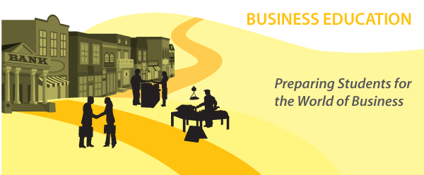
Business Education Dept.
Manchester High School
405 5th Avenue
Manchester, Ga. 31816
Sandra.hussie@mcssga.org

Below are the 3 Pathways in Business Education:
- The Business Essentials
- Legal Environment of Business
- Entrepreneurial Ventures
- The Business Essentials: The course will help students build a strong knowledge base and develop management skills as they study forms of business ownership, functions of management, budgeting and finance, technology, communications, legislation, leadership and teamwork, marketing, and economics. Mastery of these standards through project-based learning and leadership development activities of the Career and Technical Student Organizations will prepare students with a competitive edge for the global marketplace.

- Legal Environment of Business: The second course in the Business Education Pathway, this course concentrates on the legal aspects of business ownership and management. Legal issues will include contracts, sales, consumer law, agency and employment law, personal and real property, risk management, environmental law, and government effects on business. The impact of ethics on business operations will be studied.

- Entrepreneurial Ventures: The third course in the Business Education Career Pathway. This course concentrates on the management skills necessary for successful business operation. Students study management strategies for developing and implementing business plans; structuring the organization; financing the organization; and managing information, operations, marketing and human resources. An integral component of the Entrepreneurial Ventures course is a school-based or community-based entrepreneurial venture that will engage students in the creation and management of a business and the challenges of being a small business owner.
- Work Base Learning: Work-Based Learning placements represent the pinnacle of the Career-Related Education experience. To qualify for a WBL placement, a student must be in grades 11 or 12 and at least 16 years old. Students must also have a defined Career Pathway in order to participate in a Work-Based Learning placement. This is especially important for successful completion of a student’s pathway in that their job placement is directly related to the curriculum of the pathway classes they have completed or in which they are concurrently enrolled. There are several opportunities for students to participate in work-based learning. These opportunities include employability skill development, Cooperative Education, Internship, Youth Apprenticeship, and Clinical Experiences. Students receive WBL Packet from WBL Coordination.
_______________________________________________
Student Leadership Organization: FBLA
(Future Business Leaders of America)

Why should I become a member of FBLA? 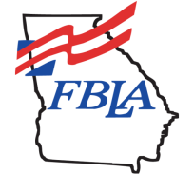
- Academics
- Leadership skills
- Academic competitions
- Scholarships
- Business Achievement Awards
- FBLA Chapter Awards and Member Recognition
- Fundraising
- Community Service work

Join FBLA: If you're interested in developing the leadership, communication, and teamwork skills at your high school, FBLA is the organization for you!!!

